**PYTHON FINAL PROJECT**

Our project is an application that will retrieve and report data according to the criteria entered from IMDB.com.

There is information that should be taken from IMDB. URL’s are individually defined based on the content of the movies. Request module is used for this operation.

In default version of this program gives the “Top Rated Movies” list. Top Rated Movies list are in descending order by the IMDB Rating. It gives the top rated first 250 movie.

The program gives user a choice to topic of movie. The user can see the list of topics from 1 to 15, the user writes the number of the topic user wants and can reach the Top Rated Movies list.

There are 15 different topics about movies:

1. Action
2. Adventure
3. Animation
4. Biography
5. Comedy
6. Crime
7. Drama
8. Family
9. Fantasy
10. History
11. Horror
12. Music
13. Romance
14. Sport
15. Western

**The Code Explanation**

* The program gets the data of IMDB. However the data cannot be read so “soup” is defined and the data becomes readable in the program. For example we can see the soup for Comedy topic:

soup_Comedy = BeautifulSoup(im_Comedy_Url.content, "html.parser")

* Each website has different data. The program wants to get readable data from IMDB. After “soup” all datas can be read from IMDB. In “data” method the program wants to get all readable data in a tabular form. For example we can see data for Comedy topic:

data_Comedy = soup_Comedy.find_all("div", {"class": "lister-item mode-advanced"})

* A while loop is started and printed to see the topics that the user will select in this loop. For example we can see the print function for Comedy topic:

print("5 - Comedy")

* An if condition is opened. According to the topic selected by the user, it was selected and printed from the information tabulated with the "data" method. For example we can see this print function for Comedy topic:

elif select == 5:

for films_Action in data_Comedy:

filmTitles = films_Action.find_all("h3", {"class": "lister-item-header"})

filmRanking = films_Action.find_all("div", {"class": "inline-block ratings-imdb-rating"})

print("Film Title: \t\t" + filmTitles[0].text.replace("\n", ""))

print("Film IMDb Rating: \t\t\t" + filmRanking[0].text.replace("\n", ""))

print("*" * 50)

* The program have to consider how user can exit the program. so that if user press 0 program will be shut down.

if select == 0:

break

* If the user does not press one of the numbers between 1 and 15. The program have to tell the user this is a wrong select.

else:

print("Wrong select2.")

i = 0

**The Results of Program**

* The default version program.

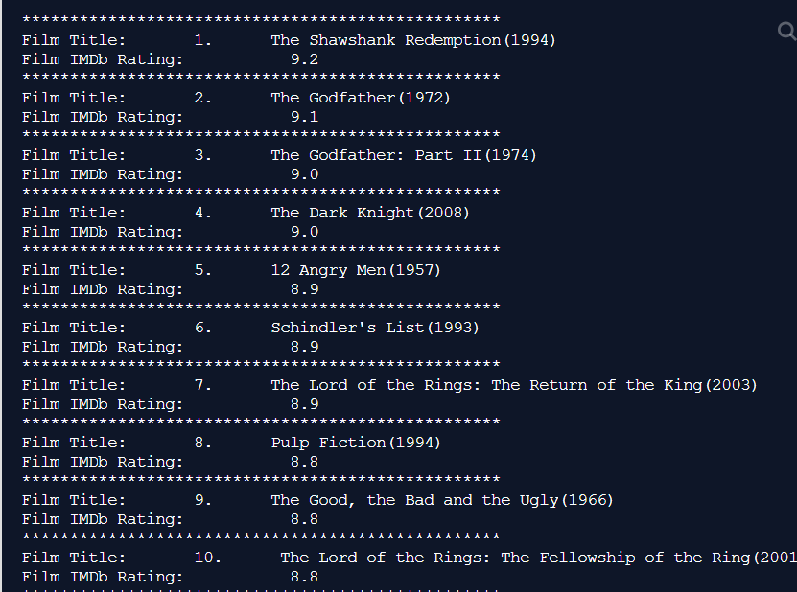

**Figure 1:** First 10 Movie of Top Rated Movies

* The user can choose anyone of this topics.

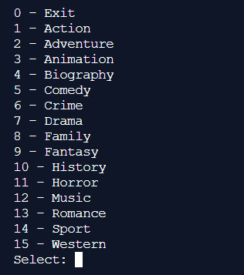

**Figure 2:** The List of Topics

* The user can choose anyone of this topics and the program will be give the list of rank of rating descending.

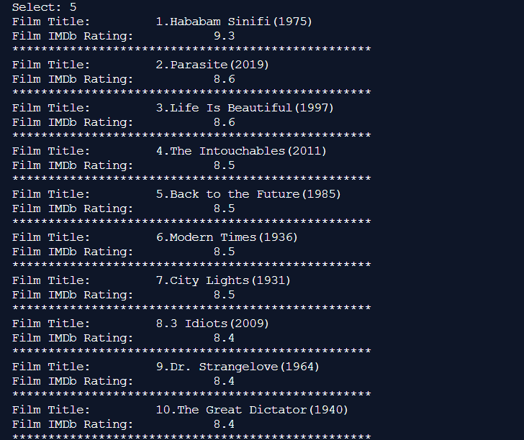

**Figure 3:** First 10 Movie in Comedy Topic

* If user wants to exit the program press 0.

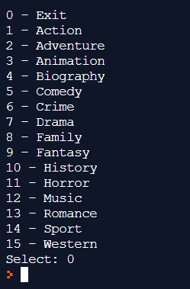

**Figure 4:** Program exited

* If the user does not press one of the numbers between 1 and 15.

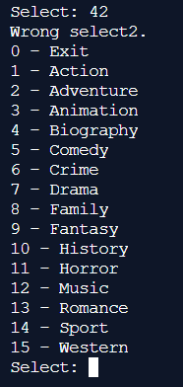

**Figure 5:** Wrong Select

|  |  |
| --- | --- |
| 170316030 | Gizem BOLAYIR |
| 170316059 | Utku ÇELEBİ |
| 170316060 | Miray HASCOŞKAN |
| 170316064 | Fatma KURTULUŞ |